**Aggregations with your Data**

The below transformations were performed using the Microsoft Azure platform using Ambari Views, specifically Hive View 2.0. Before any transformations or aggregations could be completed an HDInsight’s Cluster was created and the Video games sales data was loaded into a table called “sales”. The below aggregations take into consideration that the previously mentioned steps have already been completed.

**Step 1 (Create two tables (one for sports games and one for shooter games) displaying the average critic score):**

Use the following code to create the table for sports games average critic score:

CREATE TABLE sports_avg_critic_score  
(  
Name string,

Genre string,  
Critic_Score int   
);

INSERT OVERWRITE TABLE sports_avg_critic_score  
SELECT Name, Genre, Critic_Score  
FROM sales;

Use the following code to ensure your aggregation has been performed correctly:

SELECT AVG(Critic_Score) AS sports_critic_scrore

FROM sales

WHERE Genre LIKE "%Sports%";

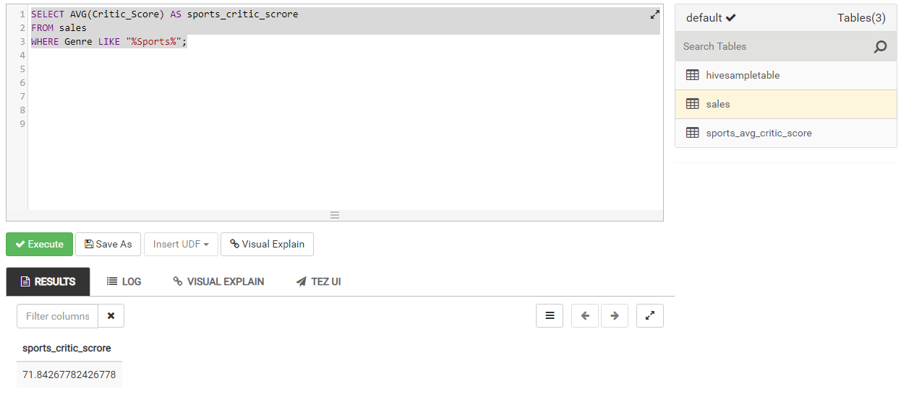

You should see a table that looks like the above.

Use the following code to create the table for shooter games average critic score:

CREATE TABLE shooter_avg_critic_score  
(  
Name string,

Genre string,  
Critic_Score int   
);

INSERT OVERWRITE TABLE shooter_avg_critic_score  
SELECT Name, Genre, Critic_Score  
FROM sales;

Use the following code to ensure your aggregation has been performed correctly:

SELECT AVG(Critic_Score) AS shooter_critic_scrore

FROM sales

WHERE Genre LIKE "%Shooter%";

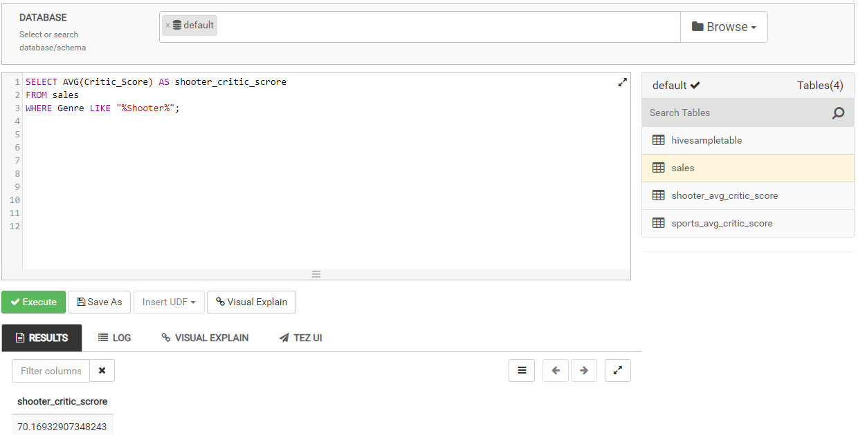

You should see a table that looks like the above.

**Step 2 (Create three statistics tables for the global sales; one for all games, one for sports games and one for shooter games):**

Use the following code to create the table for all games:

CREATE TABLE all_games_global_sales  
(  
Name string,

Genre string,  
Global_Sales float   
);

INSERT OVERWRITE TABLE all_games_global_sales  
SELECT Name, Genre, Global_Sales  
FROM sales;

Use the following code to ensure your aggregation has been performed correctly:

SELECT AVG(Global_Sales) AS average_global_sales, MIN(Global_Sales) AS min_global_sales,

MAX(Global_Sales) AS max_global_sales

FROM all_games_global_sales;

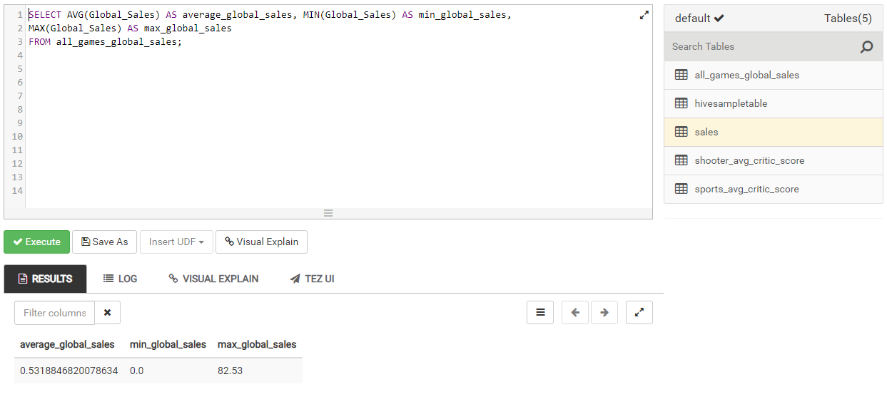

You should see a table that looks like the above.

Use the following code to create the table for sports games:

CREATE TABLE sports_games_global_sales  
(  
Name string,

Genre string,  
Global_Sales float   
);

INSERT OVERWRITE TABLE sports_games_global_sales  
SELECT Name, Genre, Global_Sales  
FROM sales;

Use the following code to ensure your aggregation has been performed correctly:

SELECT AVG(Global_Sales) AS average_global_sales, MIN(Global_Sales) AS min_global_sales,

MAX(Global_Sales) AS max_global_sales

FROM sports_games_global_sales

WHERE Genre LIKE "%Sports%";

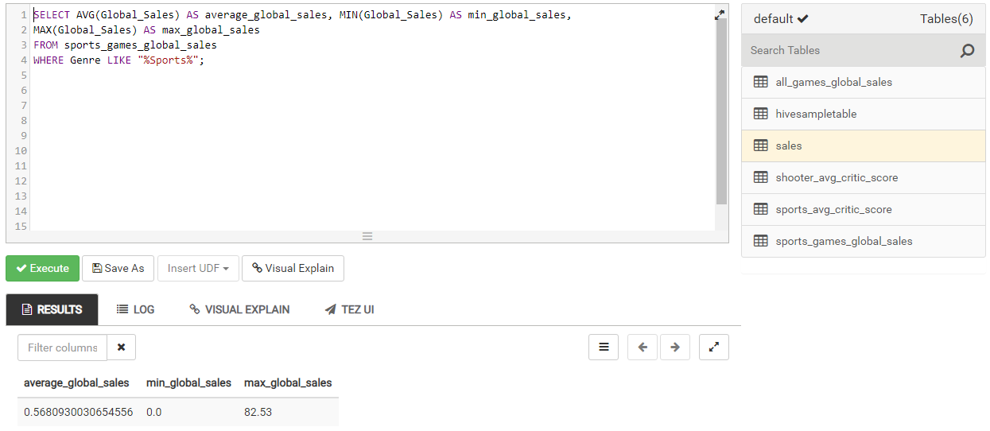

You should see a table that looks like the above.

Use the following code to create the table for sports games:

CREATE TABLE shooter_games_global_sales  
(  
Name string,

Genre string,  
Global_Sales float   
);

INSERT OVERWRITE TABLE shooter_games_global_sales  
SELECT Name, Genre, Global_Sales  
FROM sales;

Use the following code to ensure your aggregation has been performed correctly:

SELECT AVG(Global_Sales) AS average_global_sales, MIN(Global_Sales) AS min_global_sales,

MAX(Global_Sales) AS max_global_sales

FROM shooter_games_global_sales

WHERE Genre LIKE "%Shooter%";

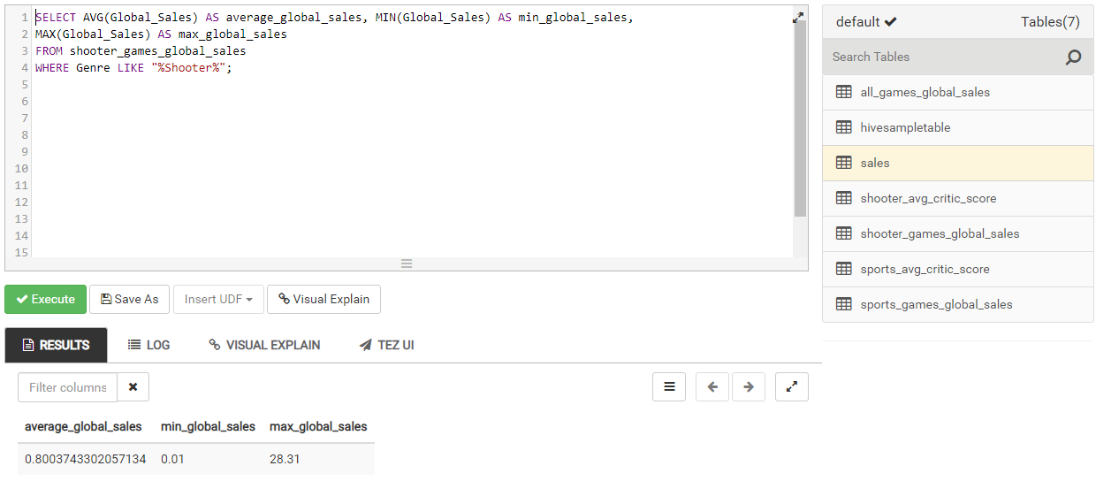

You should see a table that looks like the above.

**Step 3 (Create two tables (one for sports games and one for shooter games) for global sales and the number of games matching that global sales amount):**

Use the following code to create the table for sports games global sales:

CREATE TABLE sports_games_countglobal_sales  
(  
Name string,

Genre string,  
Global_Sales float   
);

INSERT OVERWRITE TABLE sports_games_countglobal_sales  
SELECT Name, Genre, Global_Sales  
FROM sales;

Use the following code to ensure your aggregation has been performed correctly:

SELECT Global_Sales, COUNT(Global_Sales) AS count

FROM sports_games_countglobal_sales

WHERE Genre LIKE "%Sports%"

GROUP BY Global_Sales;

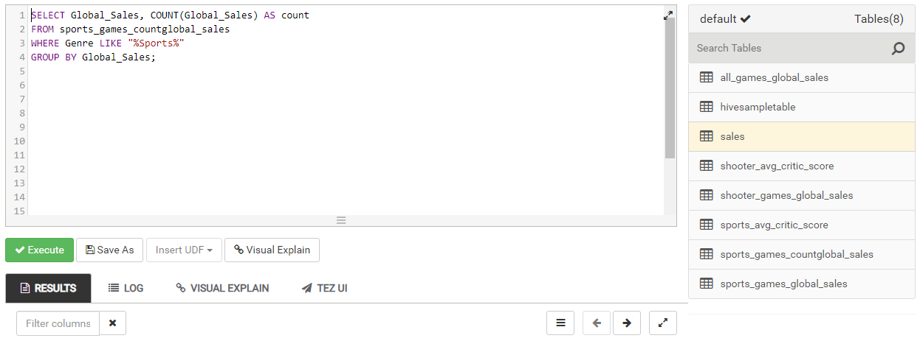

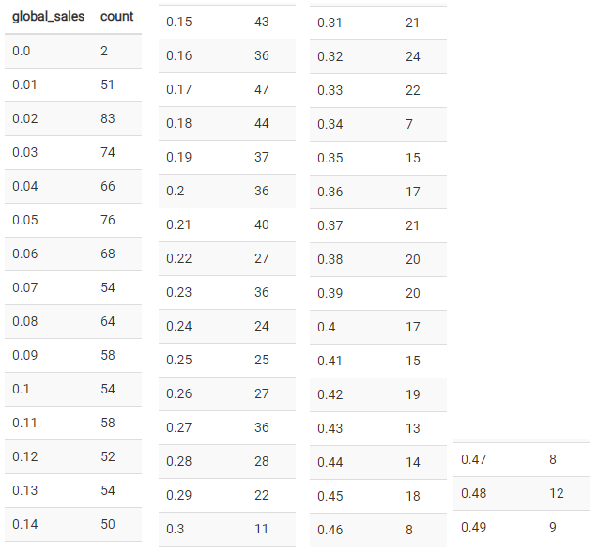

You should see a table that looks like the above.

Use the following code to create the table for sports games global sales:

CREATE TABLE shooter_games_countglobal_sales  
(  
Name string,

Genre string,  
Global_Sales float   
);

INSERT OVERWRITE TABLE shooter_games_countglobal_sales  
SELECT Name, Genre, Global_Sales  
FROM sales;

Use the following code to ensure your aggregation has been performed correctly:

SELECT Global_Sales, COUNT(Global_Sales) AS count

FROM shooter_games_countglobal_sales

WHERE Genre LIKE "%Shooter%"

GROUP BY Global_Sales;

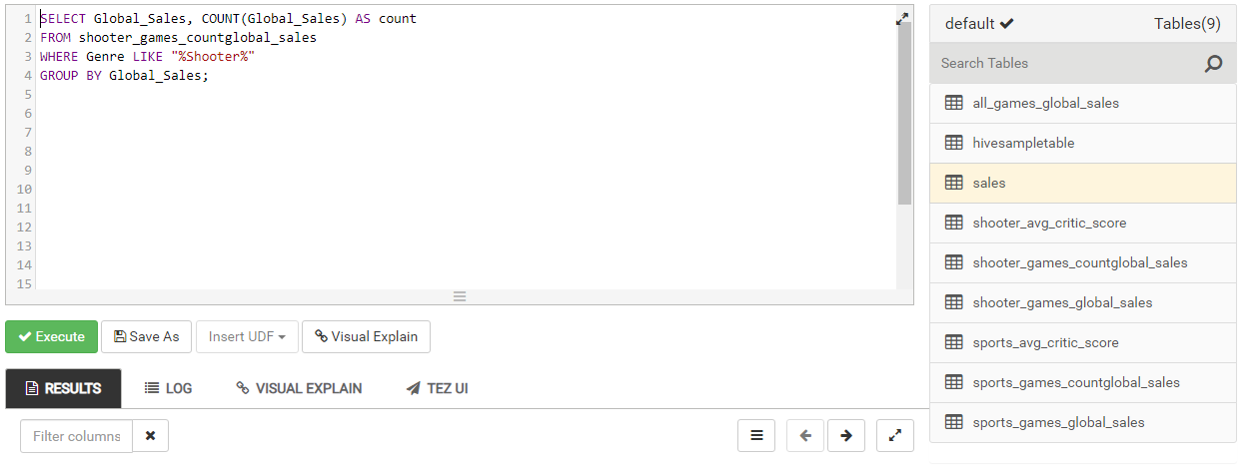

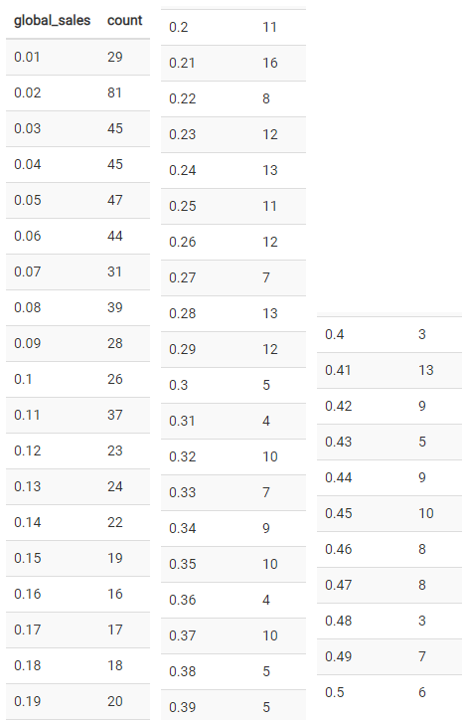

You should see a table that looks like the above.

Congratulations you have now completed all of your data aggregations!